1. Software engineering .

**SOFTWARE ENGINEERING**

* Software engineering is the application of the engineering principle to the design , development , testing and maintenance of software systems.
* It is the systemic, disciplined, cost effective technique for software development .
* Engineering approach to develop a software .

1. Explain the shortcomings of the exploratory software engineering.

* Lack of documentation
* Subjectivity and inconsistency
* Difficulty in measuring effectiveness
* Limited Scalability
* Difficulty in Reproducing Defects
* Explorer’s dilemma
* Challenging in reporting result .

1. Agile software development process :

* Agile model is being used as an umbrella term to refer to a group development processes . Agile models move quickly .
* Large project divided into small chunks means iteration .The agile models adopt an incremental and iterative approach .
* Large project -> small chunks (iteration) -> release -> feedback -> enhance -> next page.

Advantage :

. Frequently delivery

. Face to face communication.

.Time

.Changes

Disadvantage :

1 less documentation

2 maintenance problem .

1. Compare the advantage and disadvantage of the Agile model with iterative waterfall and exploratory programming model .

|  |  |  |  |
| --- | --- | --- | --- |
| Feature | Agile Model | Iterative Waterfall model | Exploratory Programming |
| Flexibility | * High | Low | High |
| Time to market | * Fast | Moderate | Variable |
| * Customer involvement | High | Low | Moderate |
| * Quality | * High | * Moderate | * Moderate |
| * Predictability * Documentation | * Low * Moderate | High  High | * Low * Low |

1. Is the life cycle model suitable for development of embedded software ?

yes, the life cycle model suitable development of embedded software .but the choice of model depends on the complexity ,requirements , and embedded system .

1. Water fall model :
2. Agile model
3. V model

* V shape model is verification model and validation model .verification phase Requirements analysis , System designing , architecture design, module design .
* Validation phase Unit testing, integration , system accepting testing .

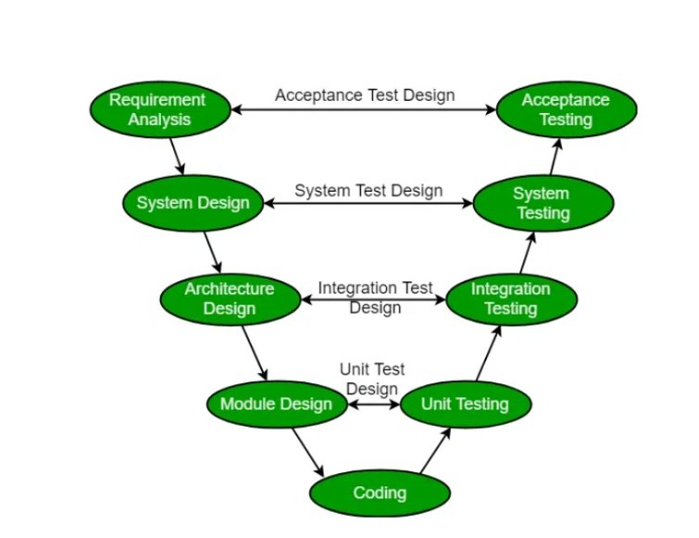

1. Spiral model
2. Iterative & incremental model
3. what is requirement engineering? State its process and explain requirements elicitation problems ?

* requirement engineering is the systematic and well define process or requirement gathering and maintenance in software system .
* requirements is refers to the requirements gathering and maintenance requirements in engineering design process .

key activities in requirements engineering

. feasibility study

. requirements gathering

. elicitation

. requirements specification

. requirements validation

. requirements analysis .

Requirements elicitation is critical but challenging phase in software development .

Misunderstanding

Poor Miscommunication

Hidden requirements

Multiple elicitation techniques

Lack of stack holder

Prototyping and user feedback

1. What is cocomo model?

The Constructive Cost Model (COCOMO) is a widely used software cost estimation model. It helps predict the effort, cost, and schedule required for a software development project.

**Advantages:**

* **Relatively Simple:** Basic COCOMO is easy to understand and apply.
* **Widely Used:** A well-established and widely recognized model in the software industry.
* • **Accuracy Depends on Data:** The accuracy of COCOMO estimates relies heavily on the quality and relevance of historical data used to calibrate the model.
* • **Limited to Software Projects:** COCOMO is specifically designed for software development projects and may not be suitable for other types of projects.